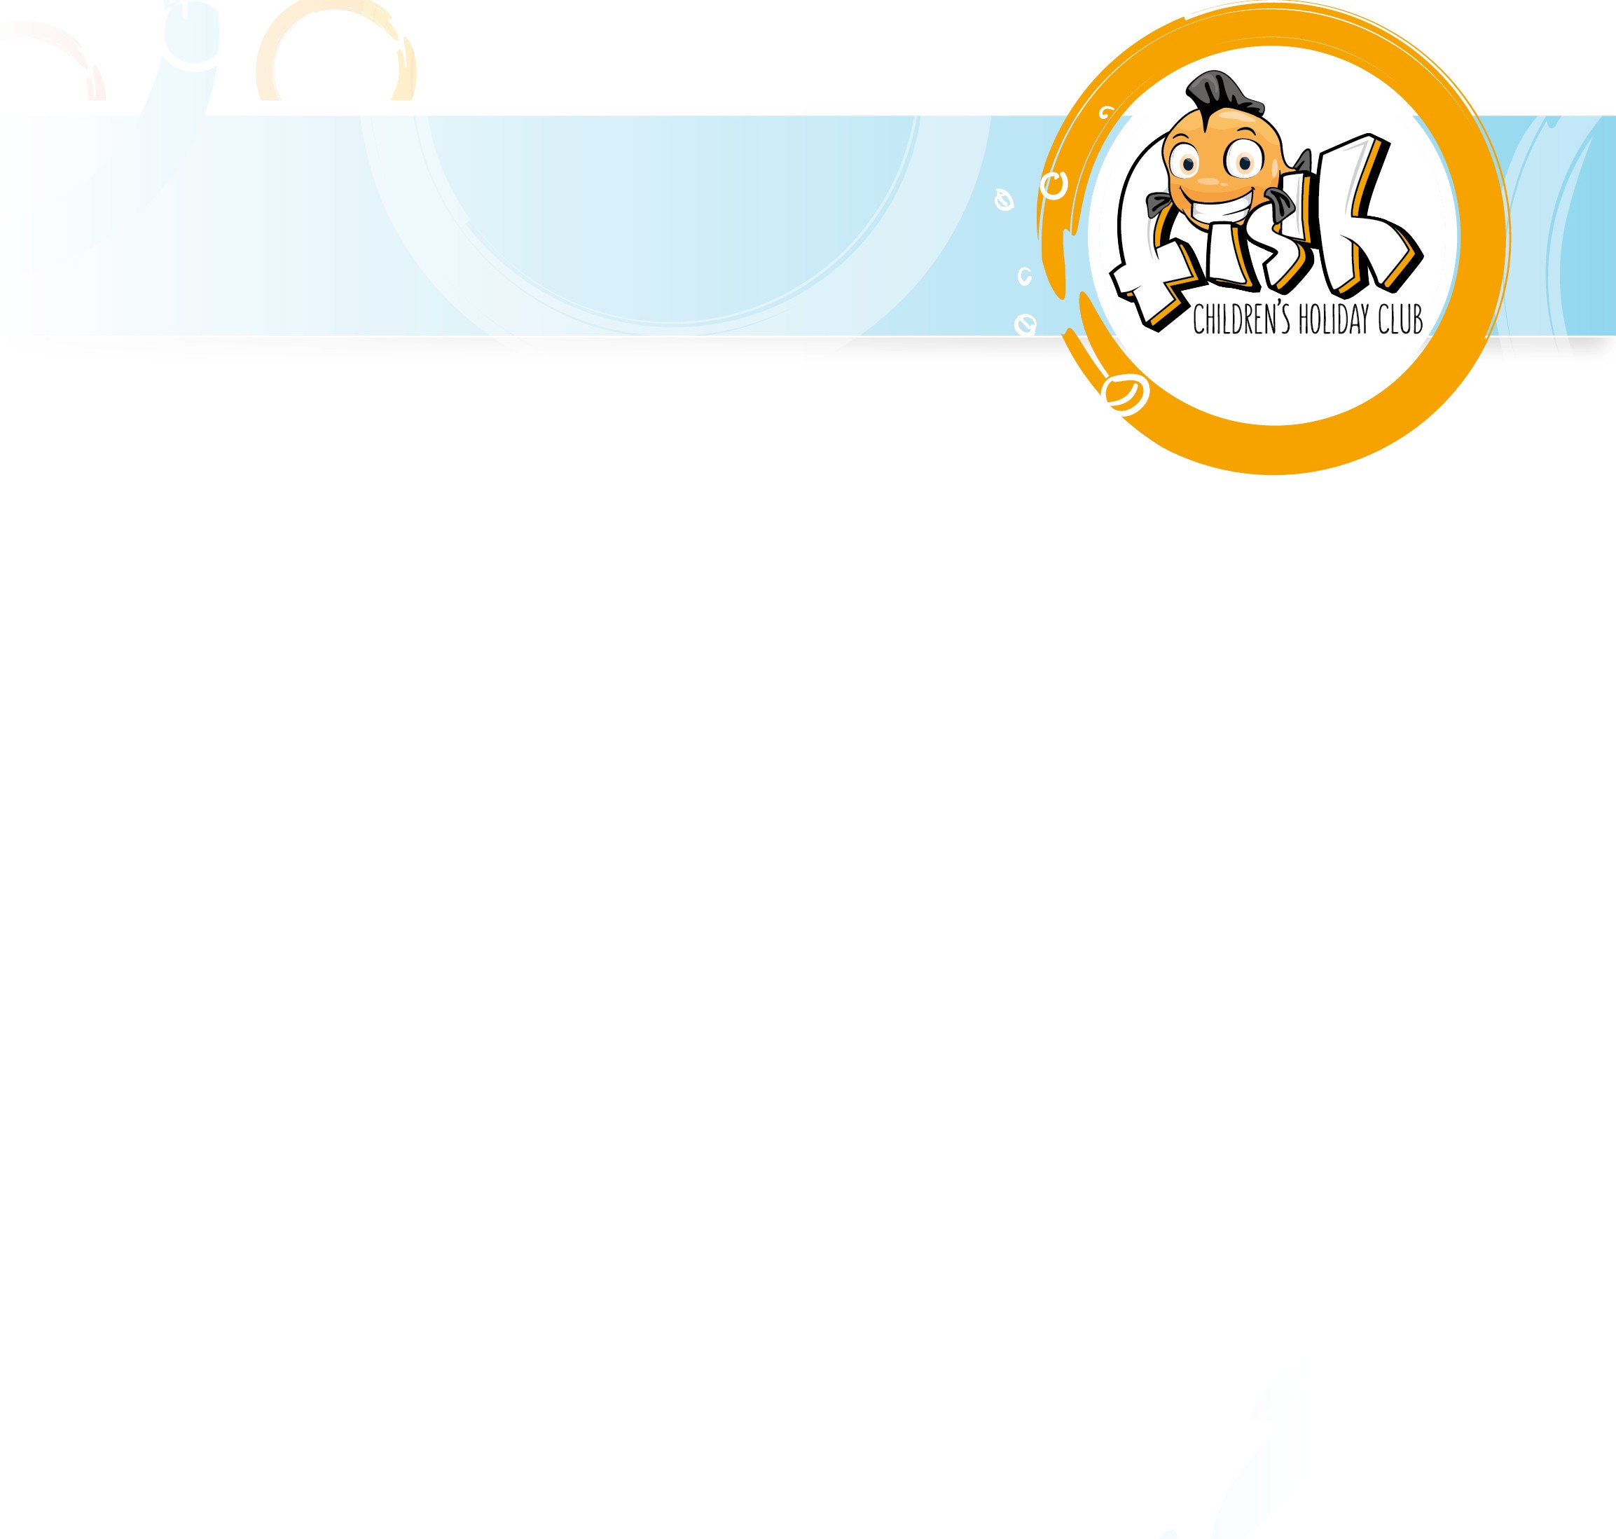

Staff Agreement to Policies

Please read the following statement, and sign & date each section if you agree.

“I have read and fully support Fun In School Holidays (F.I.S.H.) policies and procedures as listed below, as an employee of F.I.S.H I will adhere to these policies and procedures”:

1. Organisation | Sign: | Date:
2. Staff | Sign: | Date:
3. Staff Children | Sign: | Date:
4. Care, Learning, and Play | Sign: | Date:
5. Physical Environment | Sign: | Date:
6. Equipment | Sign: | Date:
7. Health & Safety | Sign: | Date:
8. Arrival & Departure | Sign: | Date:
11. Swimming Policy | Sign: | Date:
12. Outing Transport Policy | Sign: | Date:
13. Jewellery | Sign: | Date:
14. Fire Safety | Sign: | Date:
15. Good Health | Sign: | Date:
16. Administration of Short Term Medicine | Sign: | Date:
17. Inclusion Policy | Sign: | Date:
18. Equal Opportunities | Sign: | Date:
19. Special Need (Educational & Physical) | Sign: | Date:
20. Behaviour | Sign: | Date:
21. Working in Partnership (Parents & Carers) | Sign: | Date:
22. Child Protection | Sign: | Date:
23. Complaints Procedure | Sign: | Date:
24. Walking Bus | Sign: | Date:
25. Use Of Minibuses | Sign: | Date:
26. Lost Property/Damage | Sign: | Date:
27. Every Child Matters | Sign: | Date:
28. Accident Report Form: | Sign: | Date:
29. Daily Cleaning Schedule: | Sign: | Date:
Print Name: | Sign | Date

